Experiment No. – 6
Date of Performance:
Date of Submission:
Program Execution/  formation/  correction/  ethical practices  (06) | Timely  Submission  (01) | Viva  (03) | Experiment  Total (10) | Sign with Date

Experiment No. 6
Data visualization/ exploratory data analysis tools by using ANN or CNN.

1.1 Aim: Implementation of data visualization/ exploratory data analysis tools by using ANN or CNN.

1.2 Course Outcome::Implement Deep Learning techniques.

1.3 Learning Objectives: Develop real life applications using learning concepts.

1.4 Requirement:Python (Google Colab)

1.5 Related Theory:

Convolutional Neural Network (CNN)
A Convolutional Neural Network (CNN) is a powerful deep learning algorithm tailored for image and video processing tasks. This innovation draws inspiration from the intricate workings of the human visual cortex, a segment of the brain responsible for processing visual information from the external world. CNNs, like the visual cortex, are composed of multiple layers, each with its unique function, working harmoniously to extract, learn, and interpret features from images and videos. Here, we'll delve into the essential components and functioning of CNNs in a comprehensive yet concise manner.
Components of CNN:

Input Layer: This is where the CNN receives its input, which can be grayscale or RGB images. Every image consists of pixels with intensity values ranging from 0 to 255. It's crucial to normalize these values to a range between 0 and 1 before feeding them into the model.
Convolution Layer: The heart of the CNN, the convolutional layer, applies filters (also known as kernels) to the input image repeatedly. These filters are designed to detect specific features like edges or shapes (vertical, horizontal, round). Each filter scanning across the image generates a feature map, which contains information about the presence of these features. While the example might show one filter, in practice, many filters are applied to extract diverse information from the image.
Pooling Layer: After the convolutional layer, we apply a pooling layer to reduce the dimensions of the feature maps. Pooling helps retain essential information while significantly reducing computational complexity. The two most common types of pooling are Max Pooling and Average Pooling. Max Pooling selects the maximum value from a group of pixels, while Average Pooling computes the average. Both result in lower-resolution versions of the input, maintaining critical elements.
Fully Connected Layer: Having completed the feature extraction steps, the CNN moves on to the classification phase. Similar to traditional Artificial Neural Networks (ANNs), the fully connected layer connects information from the previous layers to the output layer. This step classifies the input into the desired label or category.
CNN Workflow:

The CNN workflow consists of two main phases:

Feature Extraction: In this phase, various filters and layers, including convolution and pooling, are applied to the input images. These operations aim to extract pertinent information and features. The convolutional layer creates feature maps representing detected features in the image, and pooling reduces the feature map dimensions.
Classification: After feature extraction, the CNN employs a fully connected layer to classify the input based on the learned features. This final layer connects the extracted information to the output layer, enabling the CNN to make predictions or assign labels.
Advantages of CNN over ANN:

CNNs excel in handling images and videos compared to standard Artificial Neural Networks (ANNs) due to several reasons:Efficient Image Processing: CNNs are specifically designed for image-related tasks, making them computationally efficient for working with large-size images and various image channels.
Capturing Spatial Dependencies: CNNs excel at capturing spatial dependencies within images, allowing them to understand the context and relationships between different parts of an image.Robust to Object Location Changes: Unlike ANNs, CNNs are less sensitive to changes in the location or position of objects within an image, making them more versatile in object recognition tasks.In conclusion, Convolutional Neural Networks are a cornerstone in the field of computer vision and image processing. Their architecture, inspired by the human visual cortex, enables them to effectively extract and interpret features from images and videos, making them indispensable in various applications, from image classification to object detection and beyond.

1.6 Procedure:
We will import our dataset with the help of pandas.Find out the last 5 rows of our datasets.We check for the data types, and also drop the irrelevant columns which are not required to train the model.
We will perform ANN and CNN On a given dataset.

1.7 Output:

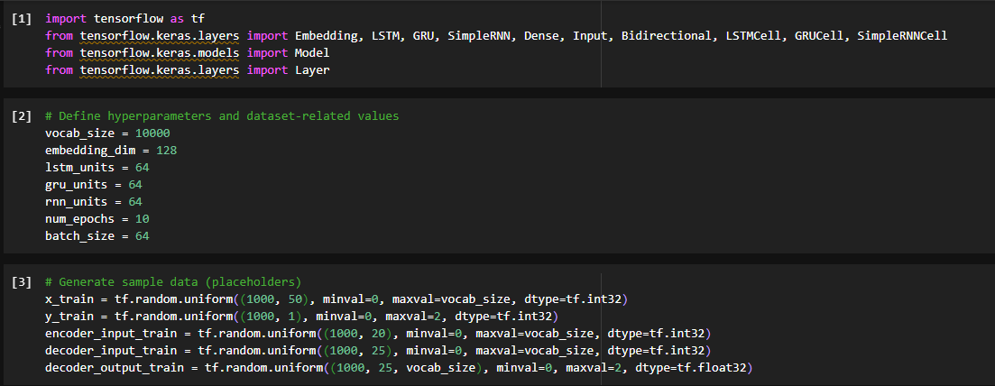

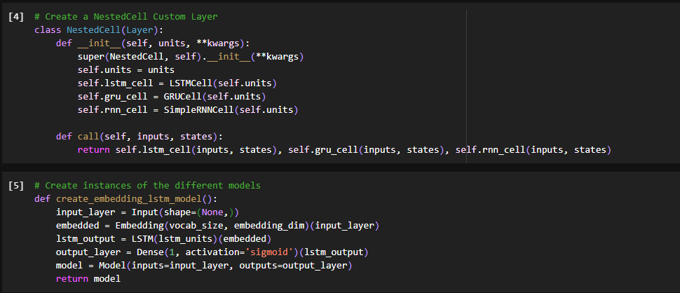

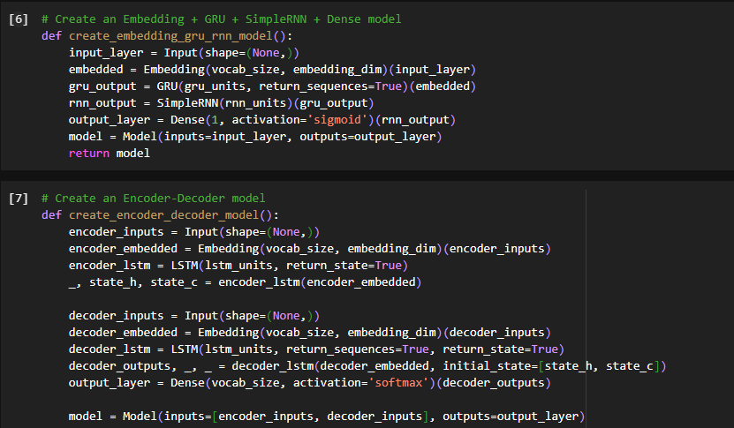

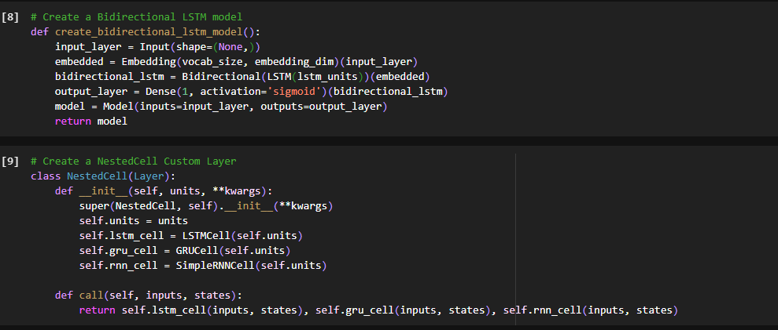

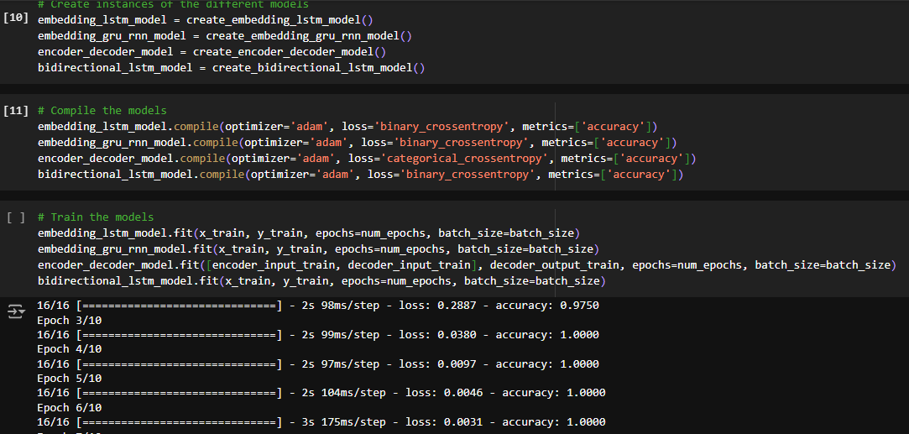

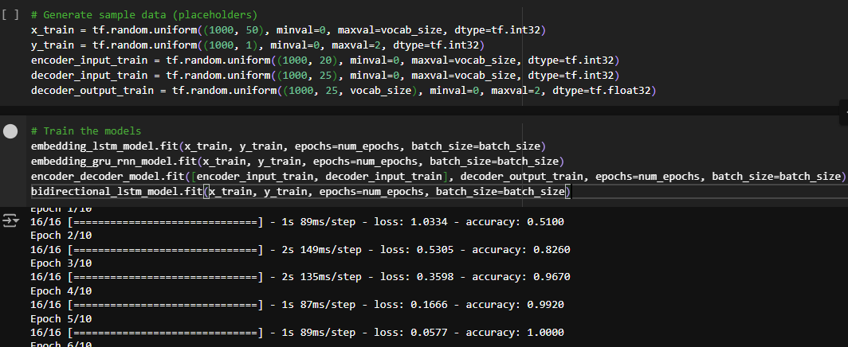

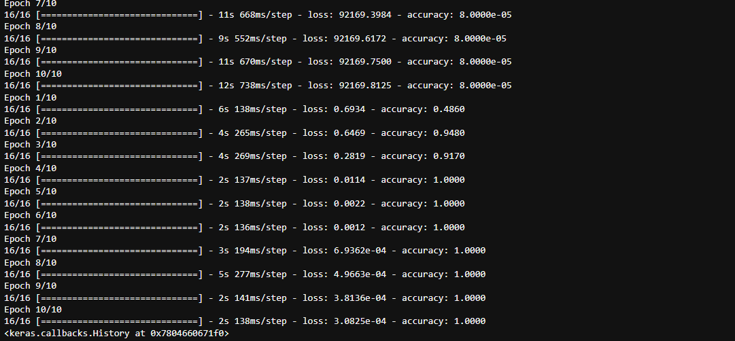

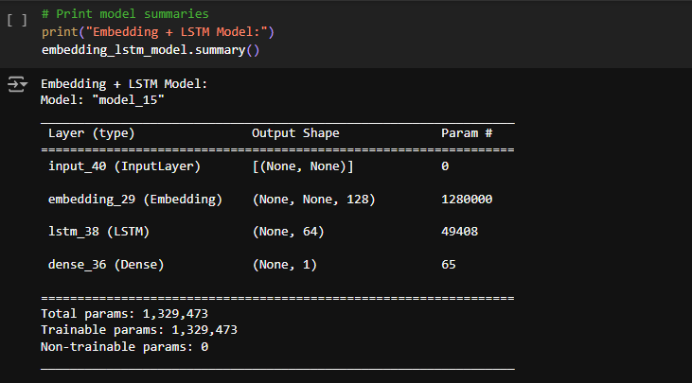

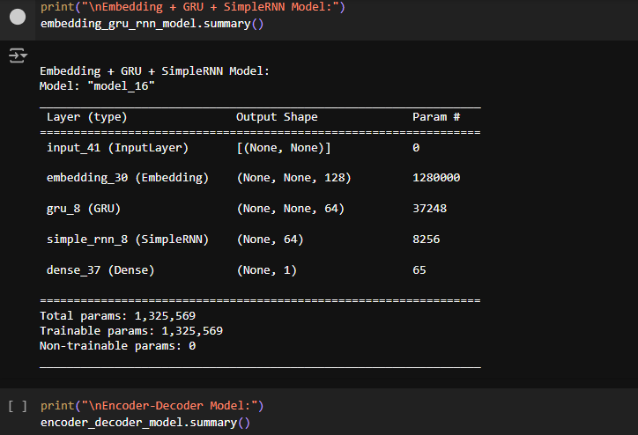

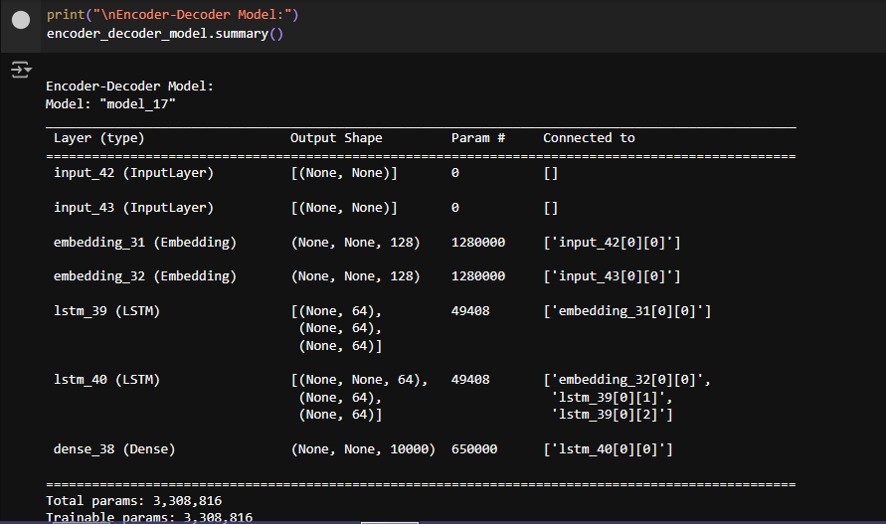

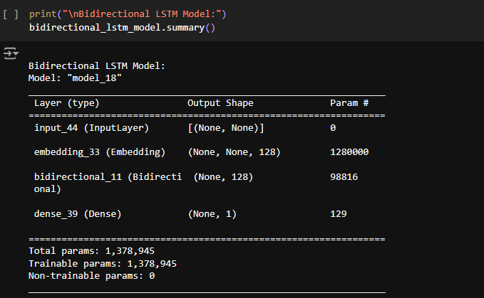

1.8 Conclusion:
In this experiment, we explored the use of Artificial Neural Networks (ANN) and Convolutional Neural Networks (CNN) for data visualization and exploratory data analysis. We demonstrated how to train both models on the MNIST dataset and visualized the training process and feature maps learned by the CNN. While ANNs are useful for structured data, CNNs are highly effective for image data, as they can learn complex spatial hierarchies in the input data. By visualizing feature maps, we can gain insights into how CNNs process data, making them a valuable tool for understanding and analyzing large, complex datasets.

1.9 Questions:
1.Explain ANN and CNN.
Ans:
ANN
Artificial Neural Networks (ANNs) are computational models inspired by biological neural networks. They consist of interconnected nodes (neurons) organized in layers: an input layer, one or more hidden layers, and an output layer.
Key Features:
- Input Layer: Receives the input data.
- Hidden Layers: Process the input data using weighted connections.
- Output Layer: Produces the final predictions or classifications.
ANNs are trained using backpropagation, adjusting the weights based on the error between predicted outputs and actual labels using a loss function. ANNs are widely used in various applications, including finance, healthcare, and natural language processing.

CNN:
Convolutional Neural Networks (CNNs) are specialized neural networks primarily used for processing structured grid data, particularly images. They excel at recognizing patterns and features in visual data.
Key Features:
- Convolutional Layers: Apply filters (kernels) to detect patterns such as edges and textures.
- Pooling Layers: Reduce spatial dimensions, retaining important features while lowering computational costs.
- Fully Connected Layers: Connect all neurons from the previous layer to output classes or predictions.
CNNs are widely used in image classification, object detection, and image segmentation, making them essential in computer vision tasks.

2.Show the difference between ANN and CNN.
Ans:
Feature | Artificial Neural Network (ANN) | Convolutional Neural Network (CNN)
Structure | Composed of fully connected layers (input, hidden, output) | Composed of convolutional, pooling, and fully connected layers
Input Type | Can handle various data types (e.g., tabular data, time series) | Primarily designed for grid-like data (e.g., images)
Operation | Uses matrix multiplication for all layers | Uses convolution operations to extract features
Feature Extraction | Requires manual feature extraction or preprocessing | Automatically extracts features through convolutional layers
Weight Sharing | No weight sharing among neurons | Uses weight sharing in convolutional layers to reduce parameters
Spatial Hierarchy | Does not capture spatial hierarchy | Captures spatial hierarchies, making it effective for images
Computational Complexity | Generally simpler; computationally less intensive | More complex due to convolutional operations; requires more computational resources
Common Applications | Regression, classification tasks, and general-purpose ML | Image classification, object detection, and image segmentation
Performance | May struggle with high-dimensional data without feature engineering | Excels in tasks involving images and visual data due to its architecture

